The Scientific Method

Question or Problem

Research

Hypothesis
Think!
Try Again!

Conduct an experiment

Analyze your data

Conclusion
Conclusion

Hypothesis is correct
Hypothesis is partially correct or wrong

Report your results

Introduction to the Scientific Method Worksheet

Long ago, many people believed that living things could come from nonliving things. They thought that worms came from wood and that maggots came from decaying meat. This idea was called spontaneous generation. In 1668, an Italian biologist, Francesco Redi, did experiments to prove that maggots did not come from meat. One of his experiments is shown below.

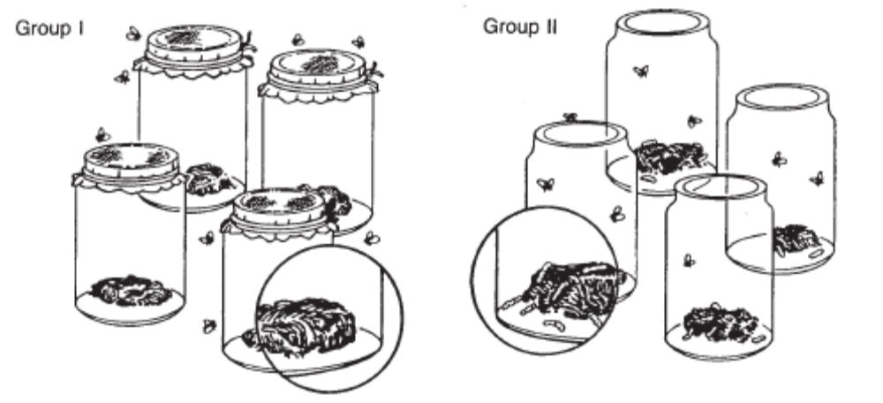
Group I
Group II

Redi placed pieces of meat in several jars. He divided the jars into two groups. He covered the first group of jars with fine cloth. He left the second group of jars uncovered. Redi observed the jars for several days. He saw flies on the cloth of the covered jars, and he saw flies laying eggs on the meat in the uncovered jars. Maggots appeared only on the meat in the group of jars left uncovered.

Questions

1. Which is not a step in the scientific method?

a. Problem or question. c. Ask other people for their opinion.
b. Research. d. Arrive at a conclusion.

2. What was the problem in Redi’s experiment?

a. How do maggots appear in meats?
b. How do worms appear in wood?
c. Is spontaneous generation a valid explanation for maggots in meats?
d. All of the above are examples of problems.

3. What do you think his hypothesis was?

a. Maggots grow through spontaneous generation.
b. Maggots come from eggs laid by flies.
c. Maggots find their way into woods and meats.
d. The problem cannot be solved.

4. How did he test his hypothesis?

a. He placed food in two jars, covering one jar and leaving the other uncovered.
b. He placed food in two jars and left both jars uncovered.
c. He placed food in two jars and covered both jars.
d. He put food in one jar and no food in a second jar.

5. What was the variable in his experiment?

a. Covering both jars.
b. Covering one jar and leaving the other uncovered.
c. Leaving both jars uncovered.
d. There was no variable in this experiment.

6. What do you think Redi’s conclusion was?

a. Living things come from other living things.
b. Living things are created through spontaneous generation.
c. He did not have enough data to arrive at a conclusion.

Can You Spot the Scientific Method Worksheet

Each sentence below describes a step of the scientific method. Match each sentence with a step of the scientific method listed below.

____ 7. Stephen predicted that seeds would start to grow faster if an electric current traveled through the soil in which they were planted.  ____ 8. Susan said, “If I fertilize my geranium plants, they will blossom.”  ____ 9. Jonathan’s data showed that household cockroaches moved away from raw cucumber slices.  ____ 10. Rene grew bacteria from the mouth on special plates in the laboratory. She placed drops of different mouthwashes on bacteria on each plate.  ____ 11. Kathy used a survey to determine how many of her classmates were left-handed and how many were right-handed.  ____ 12. Jose saw bats catching insects after dark. He asked, “How do bats find the insects in the dark?”  ____13. Justin wondered if dyes could be taken out of plant leaves, flowers, and stems.  ____ 14. Alice soaked six different kinds of seeds in water for 24 hours. Then she planted the seeds in soil at a depth of I cm. She used the same amount of water, light, and heat for each kind of seed.  ____15. Bob read about growing plants in water. He wanted to know how plants could grow without soil.  ____ 16. Kevin said, “If I grow five seedlings in red light, I think the plants will grow faster than the five plants grown in white light.”  ____ 17. Angela’s experiment proved that earthworms move away from light.  ____ 18. Scott said, “If acid rain affects plants in a particular lake, it might affect small animals, such as crayfish, that live in the same water.”  ____ 19. Michael fed different diets to three groups of guinea pigs. His experiment showed that guinea pigs need vitamin C and protein in their diets.  ____ 20. Kim’s experiment showed that chicken eggshells were stronger when she gave the hen feed, to which extra calcium had been added. | A. Recognize a problem  B. Form a hypothesis  C. Test the hypothesis with an experiment  D. Draw conclusions  A. Recognize a problem  B. Form a hypothesis  C. Test the hypothesis with an experiment  D. Draw conclusions

Dinosaur Scene - Observation and Inference Worksheet

A time machine has been invented that travels into the past and takes pictures, sending them to the present. You are asked to look at one of the pictures and interpret what you see.

____ 1. The volcano is erupting.  ____ 2. The camptosaurus is going to eat the stegosaurus.  ____ 3. The stegosaurus will run into the water to escape.  ____ 4. The camptosaurus is leaving tracks in the ground.  ____ 5. The ground where the camptosaurus is walking is wet.  ____ 6. There are plants growing in the water.  ____ 7. The camptosaurus is going into the water to eat the plants.  ____ 8. There is a tree growing next to the river.  ____ 9. The tree looks like a palm tree.  ____ 10. The climate is warm.  ____ 11. The stegosaurus is eating the plant.  ____ 12. The stegosaurus is an herbivore.  ____ 13. There are bones from a dead animal by the shore.  ____ 14. The camptosaurus killed the animal.  ____ 15. Some more bones are in the water.  ____ 16. The camptosaurus can’t swim and will drown.  ____ 17. Lava is corning down the sides of the volcano.  ____ 18. The camptosaurus has sharp teeth for eating meat. | A. Observation  B. Inference  A. Observation  B. Inference

Suppose you are a paleontologist and you have just discovered a layer of rock with many fossils in it, both petrified bones and tracks.

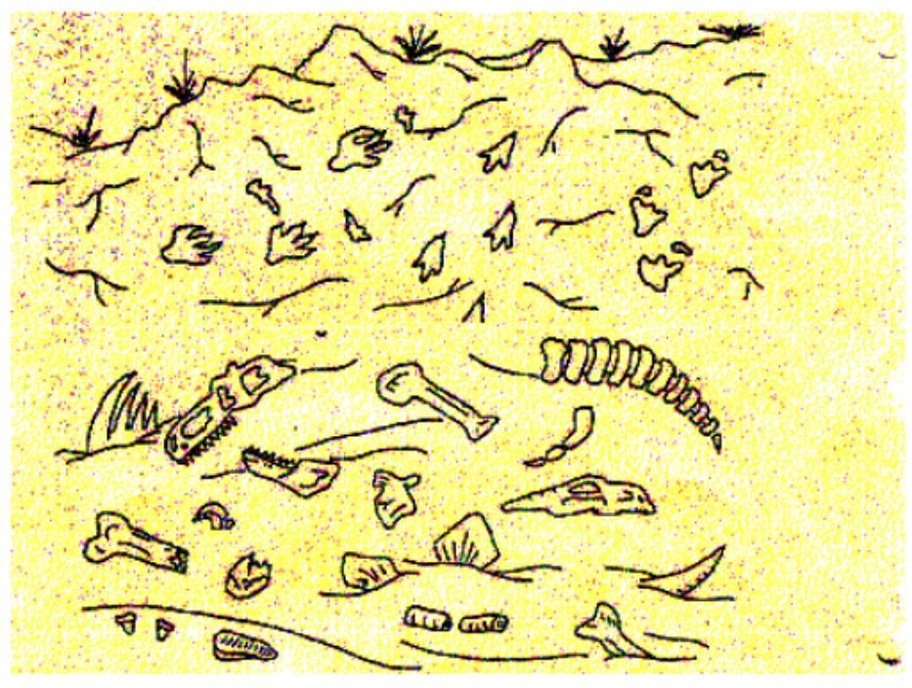

Decide whether the following statements are observations or inferences.

19. _____ There are tracks from three different animals in the rock.  20. _____ One animal was chasing another animal.  21 _____. Two different animals died in this spot.  22. _____ When the animals walked here the ground was wet.  23. _____ One of the animals that died here had bony plates.  24. _____ One of the animals that died here had sharp teeth.  25. _____ The animal that had sharp teeth ate meat. | A. Observation  B. Inference

Qualitative Observations vs. Quantitative Observations Worksheet

All of the observations in this worksheet were qualitative; that is, you observed a quality about an object (it smelled good, it was green, etc.). Another type of observation is quantitative, meaning that it can be described or measured in concrete numerical terms.

- The following observations are quantitative: There are 30 students in my class. I weigh 98 pounds. I ate a pound of potatoes.

Determine which of the following statements are quantitative and which are qualitative.

_____1. The cup had a mass of 454 grams.  _____2. The temperature outside is 250º C.  _____3. It is warm outside.  _____4. The tree is 30 feet tall.  _____5. The building has 25 stories.  _____6. The building is taller than the tree.  _____7. The sidewalk is long.  _____8. The sidewalk is 100 meters long.  _____9. The race was over quickly.  _____10. The race was over in 10 minutes. | A. Qualitative  B. Quantitative

Scientific Method - Controls and Variables
T. Trimpe 2003

Definition of Key Terms

- Control - A part of the experiment that is not being tested and is used for comparison.
- Variable - Any part of an experiment that can change.
- Independent Variable - The part of the experiment that is changed by the scientists or person performing the experiment.
- Dependent Variable - The part of the experiment that is affected by the independent variable.

SpongeBob and his Bikini Bottom pals have been busy doing a little research. Read the description for each experiment and answer the questions.
Krusty Krabs Breath Mints

Mr. Krabs created a secret ingredient for a breath mint that he thinks will “cure” the bad breath people get from eating crabby patties at the Krusty Krab. He asked 100 customers with a history of bad breath to try his new breath mint. He had fifty customers (Group A) eat a breath mint after they finished eating a crabby patty. The other fifty (Group B) also received a breath mint after they finished the sandwich; however, it was just a regular breath mint and did not have the secret ingredient. Both groups were told that they were getting the breath mint that would cure their bad breath. Two hours after eating the crabby patties, thirty customers in Group A and ten customers in Group B reported having better breath than they normally had after eating crabby patties.

1. Which people are in the control group?

a. Group A b. Group B

2. What is the variable?

a. The actual breath mint. c. The secret ingredient in the breath mint.
b. The crabby patties. d. How many crabby patties eaten.

3. What should Mr. Krabs’ conclusion be?

a. The breath mint with the secret ingredient does reduce breath odor.
b. The breath mint with the secret ingredient reduces breath odor over 50% of
the time.
c. The breath works, but it is not 100% effective.
d. All of the above.

SpongeBob Clean Pants

SpongeBob noticed that his favorite pants were not as clean as they used to be. His friend Sandy told him that he should try using Clean-O detergent, a new laundry soap she found at Sail-Mart.

SpongeBob made sure to wash one pair of pants in plain water and another pair in water with the Clean-O detergent. After washing both pairs of pants a total of three times, the pants washed in the Clean-O detergent did not appear to be any cleaner than the pants washed in plain water.

4. What was the problem SpongeBob wanted to investigate?

a. Is Clean-O detergent effective?
b. Is the length of time the pants are washed important?
c. How does water temperature affect cleaning pants?
d. Does how often I wash my pants affect how clean they are?

5. What is the variable?

a. Water temperature. c. Laundry soap
b. Length of wash time. d. Size of washing tub.

6. What should Sponge Bob’s conclusion be?

a. Clean-O best cleans his pants.
b. Plain water best cleans his pants.
c. Cold water best cleans his pants.
d. Clean-O is not effective cleaning his pants.

Squidward’s Symphony

Squidward loves playing his clarinet and believes it attracts more jellyfish than any other instrument he has played. In order to test his hypothesis, Squidward played a song on his clarinet for a total of 5 minutes and counted the number of jellyfish he saw in his front yard. He played the song a total of three times on his clarinet and repeated the experiment using a flute and a guitar. He also recorded the number of jellyfish he observed when he was not playing an instrument. The results are shown in the chart.

Number of Jellyfish/Instrument
Trial | No Music | Clarinet | Flute | Guitar
1 | 5 | 15 | 5 | 12
2 | 3 | 10 | 8 | 18
3 | 2 | 12 | 9 | 7

7. What is the variable?

a. Number of jellyfish. c. Length the music was played.
b. Instrument. d. The song he played.

8. What should Squidward’s conclusion be?

a. The clarinet and guitar attracted the same number of jellyfish.
b. The flute attracted more fish than the control (no music).
c. Music attracts more jellyfish than does no music.
d. All of the above.

Super Bubbles

Patrick and SpongeBob love to blow bubbles! Patrick found some Super Bubble Soap at Sail-Mart. The ads claim that Super Bubble Soap will produce bubbles that are twice as big as bubbles made with regular bubble soap. Patrick and SpongeBob made up two samples of bubble solution. One sample was made with 5 oz. of Super Bubble Soap and 5 oz. of water, while the other was made with the same amount of water and 5 oz. of regular bubble soap. Patrick and SpongeBob used their favorite bubble wands to blow 10 different bubbles and did their best to measure the diameter of each one. The results are shown in the chart

Bubbles
(Diameter in centimeters)
Bubble | Super Bubble | Regular Soap
1 | 15 | 10
2 | 10 | 5
3 | 12 | 16
4 | 18 | 14
5 | 22 | 11
6 | 13 | 12
7 | 16 | 11
8 | 18 | 15
9 | 15 | 15
10 | 12 | 6

9. What did the Super Bubble ads claim?

a. Super Bubble produces bubbles twice as large as regular bubble soap.
b. Super Bubble makes twice as many bubbles as regular bubble soap.
c. Super Bubble bubbles last twice as long as bubbles made using regular bubble
soap.
d. Super Bubble is cheaper than regular bubble soap.

10. What is the variable?

a. Bubble size. c. Length of time bubbles last.
b. Number of bubbles made. d. Type of bubble solution.

11. What should their conclusion be?

a. Super Bubble solution did not produce bubbles twice as large as those made
with regular bubble soap.
b. Regular bubble soap lasts twice as long as Super Bubble.
c. Bubbles made with Super Bubble last twice as long as bubbles made with
regular bubble soap.
d. There was no difference between Super Bubble and regular bubble soap.
Slimotosis

Sponge Bob notices that his pal Gary is suffering from slimotosis, which occurs when the shell develops a nasty slime and gives off a horrible odor. His friend Patrick tells him that rubbing seaweed on the shell is the perfect cure, while Sandy says that drinking Dr. Kelp will be a better cure. Sponge Bob decides to test this cure by rubbing Gary with seaweed for 1 week and having him drink Dr. Kelp. After a week of treatment, the slime is gone and Gary’s shell smells better.

12. What was the initial observation?

a. Gary’s shell is dull in color and hard to see.
b. Gary’s shell is glowing in the dark.
c. Gary’s shell has a nasty slime and gives off a horrible odor.
d. Gary’s shell is developing holes in it.

13. What is the variable?

a. Rubbing seaweed on the shell. c. Both a and b.
b. Drinking Dr. Kelp.

14. What should Sponge Bob’s conclusion be?

a. Rubbing seaweed cured the slimotosis.
b. Drinking Dr. Kelp cured the slimotosis.
c. Both rubbing seaweed and drinking Dr. Kelp cured the slimotosis.
d. We cannot determine which cured the slimotosis. The experiment must be re-
done, testing one variable at a time.

Key Vocabulary

Analyze – Examine data collected in an experiment to determine what it means.
Conclude – Reach a decision based on the analysis of data.
Data – Information collected during an experiment.
Experiment – A test that is done to determine if a hypothesis is correct or not.
Hypothesis – Your proposed answer to the question or solution to the problem.
Inference (Infer) – Coming to a conclusion based on your existing knowledge. (Example – seeing a student wearing a sports team jersey and concluding the student likes that team.)
Observe – Watch something carefully.
Qualitative data – Data dealing with descriptions; data is observed (colors, textures, smells, tastes, appearance, beauty, etc.).
Quantitative data – Data which can be measured (length, height, area, volume, weight, speed, time, temperature, etc.).
Results – Outcome of an experiment.
Tentative – Basic results that may or may not be accurate; basic results.
Variable – Something that can be changed.
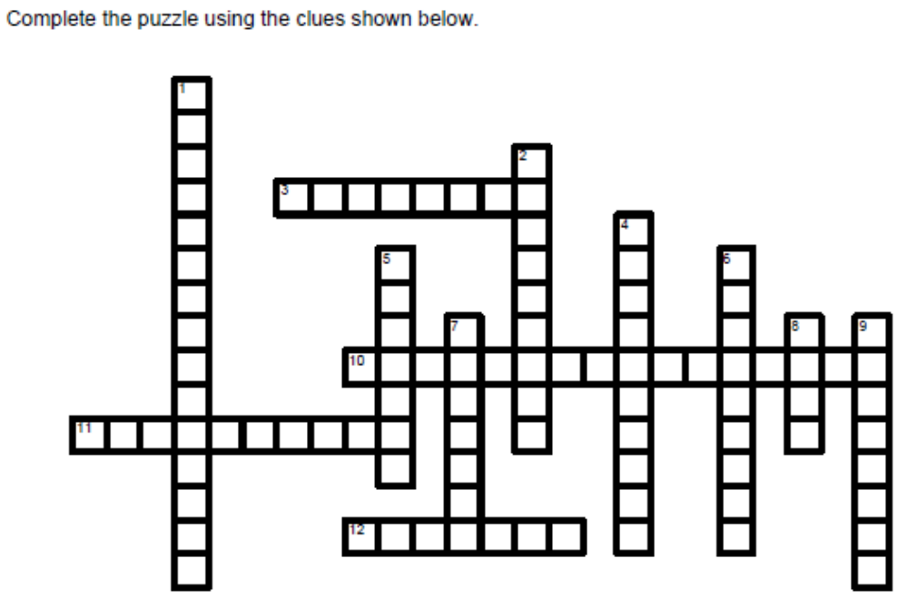
Across

3. Reach a decision based on the analysis of data.
10. Data which can be measured (length, height, area, volume, weight, speed, time, temperature,
etc.).
11. A test that is done to determine if a hypothesis is correct or not.
12. Watch something carefully.

Down

1. Data dealing with descriptions; data is observed (colors, textures, smells, tastes, appearance,
beauty, etc.).
2. Basic results that may or may not be accurate; basic results.
4. Your proposed answer to the question or solution to the problem.
5. Outcome of an experiment.
6. Coming to a conclusion based on your existing knowledge. (Example, seeing a student wearing
a sports team jersey and concluding the student likes that team.)
7. Examine data collected in an experiment to determine what it means.
8. Information collected during an experiment.
9. Something that can be changed.
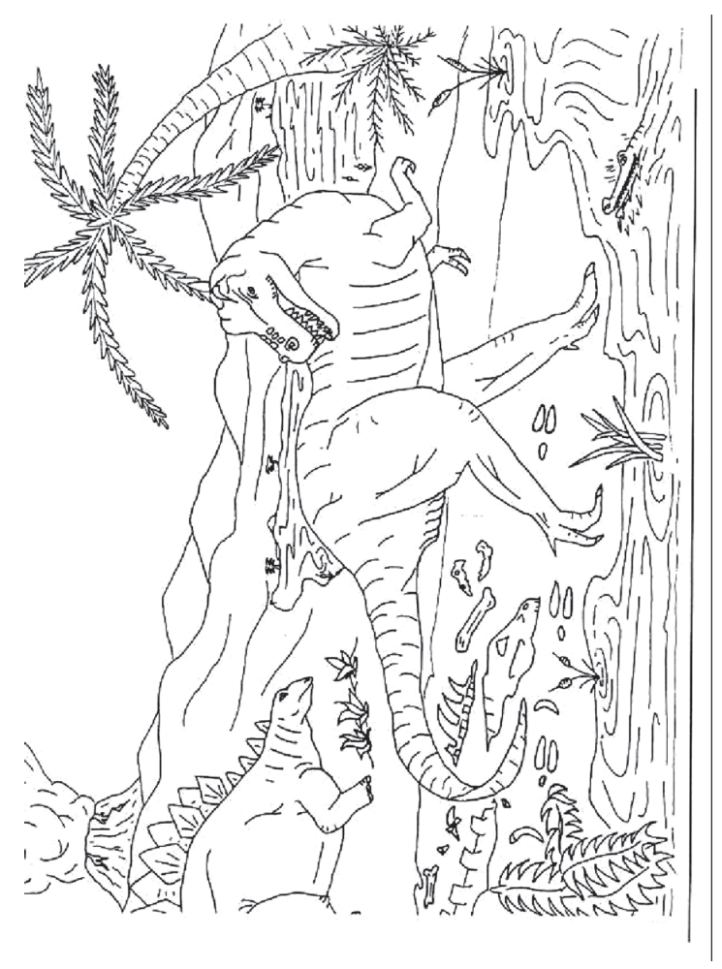
Introduction to the Scientific Method Worksheet, Can You Spot the Scientific Method Worksheet - Key

1. Which is not a step in the scientific method?
c. Ask other people for their opinion.

2. What was the problem in Redi’s experiment?

d. All of the above are examples of problems.

3. What do you think his hypothesis was?

b. Maggots come from eggs laid by flies.

4. How did he test his hypothesis?

a. He placed food in two jars, covering one jar and leaving the other uncovered.

5. What was the variable in his experiment?

b. Covering one jar and leaving the other uncovered.

6. What do you think Redi’s conclusion was?

a. Living things come from other living things. (3 choices)

B 7. Stephen predicted that seeds would start to grow faster if an electric current traveled through the soil in which they were planted.

B 8. Susan said, “If I fertilize my geranium plants, they will blossom.”

D 9. Jonathan’s data showed that household cockroaches moved away from raw cucumber slices.

C 10. Rene grew bacteria from the mouth on special plates in the laboratory. She placed drops of different mouthwashes on bacteria on each plate.

C 11. Kathy used a survey to determine how many of her classmates were left-handed and how many were right-handed.

A 12. Jose saw bats catching insects after dark. He asked, “How do bats find the insects in the dark?”

A 13. Justin wondered if dyes could be taken out of plant leaves, flowers, and stems.

C 14. Alice soaked six different kinds of seeds in water for 24 hours. Then she planted the seeds in soil at a depth of I cm. She used the same amount of water, light, and heat for each kind of seed.

A 15. Bob read about growing plants in water. He wanted to know how plants could grow without soil.

B 16. Kevin said, “If I grow five seedlings in red light, I think the plants will grow faster than the five plants grown in white light.”

D 17. Angela’s experiment proved that earthworms move away from light.

B 18. Scott said, “If acid rain affects plants in a particular lake, it might affect small animals, such as crayfish, that live in the same water.”

D 19. Michael fed different diets to three groups of guinea pigs. His experiment showed that guinea pigs need vitamin C and protein in their diets.
D 20. Kim’s experiment showed that chicken eggshells were stronger when she gave the hen feed, to which extra calcium had been added.

Dinosaur Scene - Observation and Inference Worksheet - Key

A 1. The volcano is erupting.

B 2. The camptosaurus is going to eat the stegosaurus.

B 3. The stegosaurus will run into the water to escape.

A 4. The camptosaurus is leaving tracks in the ground.

B 5. The ground where the camptosaurus is walking is wet.

A 6. There are plants growing in the water.

B 7. The camptosaurus is going into the water to eat the plants.

A 8. There is a tree growing next to the river.

A 9. The tree looks like a palm tree.

B 10. The climate is warm.

A 11. The stegosaurus is eating the plant.

B 12. The stegosaurus is an herbivore.

A 13. There are bones from a dead animal by the shore.

B 14. The camptosaurus killed the animal.

A 15. Some more bones are in the water.

B 16. The camptosaurus can’t swim and will drown.

A 17. Lava is corning down the sides of the volcano.

A 18. The camptosaurus has sharp teeth for eating meat.

A 19. There are tracks from three different animals in the rock.

B 20. One animal was chasing another animal.

A 21. Two different animals died in this spot.

B 22. When the animals walked here the ground was wet.

A 23. One of the animals that died here had bony plates.

A 24. One of the animals that died here had sharp teeth.

B 25. The animal that had sharp teeth ate meat.

Qualitative Observations vs. Quantitative Observations
Worksheet, The Process of Performing an Experiment
Worksheet - Key

B 1. The cup had a mass of 454 grams.

B 2. The temperature outside is 250 C.

A 3. It is warm outside.

B 4. The tree is 30 feet tall.

B 5. The building has 25 stories.

A 6. The building is taller than the tree.

A 7. The sidewalk is long.

B 8. The sidewalk is 100 meters long.

A 9. The race was over quickly.

B 10. The race was over in 10 minutes

Scientific Method - Controls and Variables

1. Which people are in the control group?

b. Group B (2 choices)

2. What is the variable?

c. The secret ingredient in the breath mint.

3. What should Mr. Krabs’ conclusion be?

d. All of the above

4. What was the problem SpongeBob wanted to investigate?

a. Is Clean-O detergent effective?

5. What is the variable?

c. Laundry soap.

6. What should Sponge Bob’s conclusion be?

d. Clean-O is not effective cleaning his pants.

7. What is the variable?

b. Instrument

8. What should Squidward’s conclusion be?

d. All of the above.

9. What did the Super Bubble ads claim?

a. Super Bubble produces bubbles twice as large as regular bubble soap.

10. What is the variable?

d. Type of bubble solution.
11. What should their conclusion be?

a. Super Bubble solution did not produce bubbles twice as large as those made with regular bubble soap.

12. What was the initial observation?

c. Gary’s shell has a nasty slime and gives off a horrible odor.

13. What is the variable?

c. Both a and b (3 choices)

14. What should Sponge Bob’s conclusion be?

d. We cannot determine which cured the slimotosis. The experiment must be re-done, testing one variable at a time.

Introduction to the Scientific Method Worksheet, Can You Spot the Scientific Method Worksheet

1. c  2. d  3. b  4. a  5. b  6. a (3 choices)  7. B  8. B  9. D  10. C  11. C  12. A  13. A  14. C  15. A  16. B  17. D  18. B  19. D  20. D | Scoring Guide  18-20 – 3  16-17 – 2.5  10-15 – 2  6-9 – 1  1-5 – .5  0 – 0

Dinosaur Scene - Observation and Inference Worksheet

1. A (2 choices)  2. B (2 choices)  3. B (2 choices)  4. A (2 choices)  5. B (2 choices)  6. A (2 choices)  7. B (2 choices)  8. A (2 choices)  9. A (2 choices)  10. B (2 choices)  11. A (2 choices)  12. B (2 choices)  13. A (2 choices) | 14. B (2 choices)  15. A (2 choices)  16. B (2 choices)  17. A (2 choices)  18. A (2 choices)  19. A(2 choices)  20. B(2 choices)  21. A (2 choices)  22. B (2 choices)  23. A (2 choices)  24. A (2 choices)  25. B (2 choices) | Scoring Guide  23-25 – 3  20-22 – 2.5  15-19 – 2  9-14 – 1.5  5-8 – 1  1-4 – .5  0 – 0

Qualitative Observations vs. Quantitative Observations Worksheet, The Process of Performing an Experiment Worksheet

1. B (2 choices)  2. B (2 choices)  3. A (2 choices)  4. B (2 choices)  5. B (2 choices)  6. A (2 choices)  7. A (2 choices)  8. B (2 choices)  9. A (2 choices)  10. B (2 choices) | Scoring Guide  9-10 – 3  7-8 – 2.5  6 – 2  5 – 1.5  4 – 1  1-3 – .5  0 – 0

Scientific Method - Controls and Variables

1. b (2 choices)  2. c  3. d  4. a  5. c  6. d  7. b  8. d  9. a  10.  10. d  11. a  12. c  13. c (3 choices)  14. d | Scoring Guide  12-14 – 3  10 – 11 – 2.5  6-9 – 2  4-5 – 1.5  3 – 1  1-2 – .5  0 – 0



