
Business Plan

A Pampered Pet
101 Pet Care Drive
Fishers, IN 46038

Phone 317.555.5555
www.apamperedpet.com
Contents
Executive Summary 1
Type of Business 1
Company Summary 1
Management 1
Market and Competition 1
Funds Requested 1
Collateral 1
Use of Proceeds 2
Financial Projections 2
Exit 2
Deal Structure 3
Background and Purpose 4
History 4
Current Situation 4
The Resource-based Concept 4
Objectives 5
Market Analysis 6
Overall Market 6
Specific Market 6
Competitive Factors 7
Macroenvironmental Influences 7
Development and Production 8
Facility 8
Operating Hours and Employee Ratios 8
Job Roles and Responsibilities 9
Marketing 10
Overall Concept and Orientation 10
Marketing Strategy 10
Sales Forecasts 11
Financial Plans 13
Break-Even Analysis 15
Financial Resources 15
Financial Strategy 16
Organization and Management 17
Key Personnel Resources 17
Human Resource Management Strategy 18
Ownership 19
Form of Business 19
Equity Positions 19
Deal Structure 19
Critical Risks and Contingencies 20
Conclusion 21
Summary and Conclusion 21
Scheduling and Milestones 21
Appendices 22
Appendix A – Financial Statements 22
Appendix B – Pet Care Facility Schematic 29
Appendix C – Marketing and Pricing Brochure 30
Appendix D - Population Surveys and Statistics 31
Appendix E – Competition Survey 32
Appendix F – Press Release 33
Appendix G – Owner Resumes 34

Executive Summary
The Executive Summary is the doorway to your business plan. The summary should emphasize your plan’s main points. In addition to text, you should include a chart that illustrates profits or return on investment (such as the Business Plan Highlights chart, which is automatically created when you complete the Income Statement template in the Business Plan Workbook). To display this chart, or other tables and charts, in your document, click Links on the Edit menu, and then click Update Now.
To begin the Executive Summary, select the placeholder text, and then write a paragraph or two introducing the subheadings: Objectives and Mission. Keep this section short, preferably one page.
Company:
A Pampered Pet
1 Noble Care Road
Westfield IN 46028

Type of Business
This business is involved in upscale care and overnight accommodations for domestic dogs and cats.
Setting your objectives, such as market share, sales, and profit, will determine your business goals. Make sure your objectives are concrete and measurable. They should indicate a level of sales or profits, a percentage of gross margin, a growth rate, or a market share you plan to attain. Avoid using vague objectives like “being the best” or “growing rapidly.”

Company Summary
A mission statement expresses the higher goals of your company, such as providing services to unique industries, spreading new technologies, or improving education. If your company has a mission, state it simply and in one paragraph. If you do not have a mission statement, you can develop one or delete the heading and continue to the next section.
Our primary product is premium pet care. The uniqueness of the product is in the upscale nature of the Pet Care Center. The consumer who chooses our services is interested in providing their pets distinctive care that is the same they would provide at home. Premium service and unique products are what we have to offer. Some of which are unavailable at any other like facility.

Management
Wayne Vogel, President and CEO, will hold a MBA from Anderson University. He also has an undergraduate degree from Ball State University in production and operations. Karl Knapp, Vice President and CFO will hold a MBA from Anderson University. He holds an undergraduate degree from Miami University in System Analysis. Mr. Vogel has a personal interest in the treatment and care of pets having worked in all aspects of the pet kennel industry. He has extensive contacts within this supplier market that are necessary in the start up of the business. Karl Knapp has extensive knowledge in information systems, which we plan to distinguish ourselves through unique product offerings and producing reduced operational costs.

Market and Competition
Our target market is the Indianapolis Metropolitan area, with an emphasis on the middle to high- income pet owner. A Pampered Pet is an upscale Pet Care Center designed to meet the needs of those pet owners. The market is very fragmented with many “Mom and Pop” kennels that have been started up as a hobby and grown into a family business. Their facilities are very outdated. They are unable to provide the level of care that we are proposing. The leading competitor in the market is Best Friends Boarding Kennels only due to the size of their facilities. They do not provide the types of products and services that we feel are unique to our business.

Funds Requested
A Pampered pet seeks a bank loan in the amount of $350,000 in the first year for startup capital. An additional amount of $250,000 is provided through Owner’s equity. Additional funding is needed for future facility construction.

Collateral
The bank loan is secured by the Pet Care Center facility at 70% loan to value.. Future facilities will be used as collateral in like manner.

Use of Proceeds
The proceeds of the loan combined with the Owner’s equity will be used to fund startup costs broken down as follows:

General and Administrative Expenses $23,166
Sales and Marketing Expenses 35,050
Other Expenses 5,000
Retail Inventory 1,525
Opening Cash 10,000
Land, Building and Equipment 500,000
Total $574,742

Financial Projections
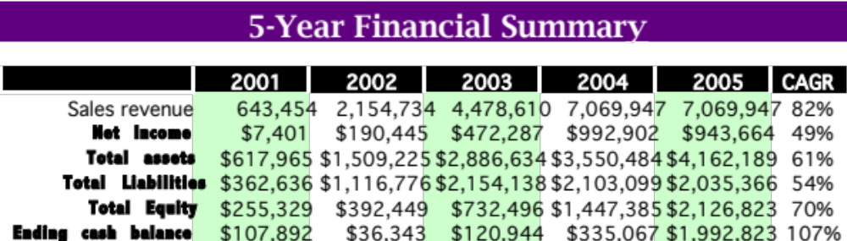
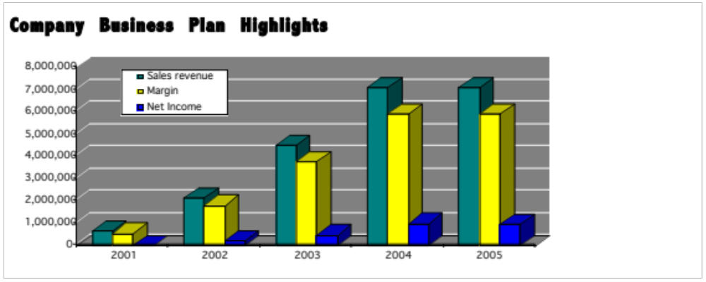

Exit
The loans are issued on a thirty-year basis. The business will be able to pay off all bank loans before the tenth year of operations.

Deal Structure

Owner Capital Contribution # of Shares %
Wayne Vogel $50,000 5,000 20%
Karl Knapp 50,000 5,000 20%
Zen Hall 50,000 5,000 20%
Emily Symmonds 50,000 5,000 20%
Chuck Storm 50,000 5,000 20%
Total $250,000 25,000 100%

Owner’s Equity - $50,000 per owner (42% of total capital) $250,000
Bank Loan (facility as collateral at 70% LTV) $350,000

Background and Purpose

History
The pet kennels market is highly fragmented with no dominant player. Most kennels are on the small side with less than 50 runs. Within the Metropolitan area, only one other kennel offers 100 runs or more. Our calculations project Dog owning households in the Indianapolis Metropolitan area for 2001 will be 192,079. We believe there is an unmet need for upscale Pet Care Centers. Few kennels offer the upscale services that we propose. We believe this to be important based on certain societal trends that are a driving force in this industry. Baby Boomers have become the dominant generation and their relative prosperity is propelling a cultural shift that will affect virtually every industry. The impact on Pet Care Centers and the pet industry in general from this societal change has been tremendous. As baby boomers finish paying for the bulk of their children’s education and upbringing, they are turning their considerable attentions and disposable incomes to their pets. Pet industry revenues will triple over the next five to ten years as more and more boomers experience empty-nest syndrome. With annual revenues of $23 billion in the U.S. alone, today’s pet industry is bigger than toy making ($20 billion) and vitamin supplements ($16 billion). No wonder – according to the last census, 60 percent of the U.S. population lives with one or more pets, and for many, their pets are their children. Many of today’s pet lovers are not bargain hunters. The most expensive brands and services are experiencing the fastest growth. Pet ownership is filling the void created by the empty-nest syndrome. However, baby boomers have not given up their quest for entertainment. Pet owners want to know that their pets are well taken care of while they are indulging their thirst for entertainment. Thus ‘A Pampered Pet’ came into being to meet the needs of this market.

Current Situation
A Pampered Pet is an upscale Pet Care Center designed to meet the needs of those pet owners who desire a level or service that is considered above the standard kennel offerings. We propose to offer a clean and well designed facility that offers such items as individualized exercise sessions for their pets, premium pet food for their pets meals and the feeling that we are their pets ‘Home away from home’. Our tag line associated with our Company name, A Pampered Pet, will be The noblest treatment of animals’. Our Pet Care Centers will be marketed towards the baby boomer generation who have turned their attention to their pets and have the disposable income to make use of our services. We intend to saturate the Metropolitan area within the next five years with Pet Care Centers strategically placed along eight exit and entry points leading out of the area from the North, South, East, and West. This will allow easy access to our facilities and help to consolidate the fragmented situation that exists today.

The Resource-based Concept
The founders of A Pampered Pet have a level of vision, creativity, drive, and intelligence that are unique for this industry. They have correctly surmised the driving force of societal trends impacting this industry and recognize this unexploited market niche.
President and CEO Wayne Vogel brings an enormous amount of knowledge and expertise. Having grown up working in all aspects of the pet kennel industry, Mr. Vogel is intimately familiar with the driving forces behind the unmet market niche of upscale pet kennels. Mr. Vogel’s contacts within the supplier market to these industry and construction trends in pet kennel facilities promise unique access to economies of scale capabilities.
With A Pampered Pet being marketed specifically as an upscale Pet Care facility, it will garner enormous first mover brand loyalty. With continued marketing activities, A Pampered Pet and its tag line, ‘The noblest treatment of animals’, will become synonymous with being the Marriott of pet kennels.

Objectives
The strategic objective of the company is to become the preferred choice for providing high-quality pet care for the pampered pet. The management’s vision is to also provide pet owners with peace of mind about their pets’ welfare and happiness during their stay at the kennel. By the end of the fifth year it is our goal to have a kennel located at each major interstate intersection coming into Indianapolis Metropolitan area. These logistics will then enable growth that will move toward saturating the market.

Market Analysis
Our analysis of the market shows that the pet care industry is a very fragmented industry with an average occupancy rate of 51.7%. There are many small family-owned businesses within our target area. We believe that we will be able to achieve a market share that will enable us to be a market leader where economies of scale can be achieved.

Overall Market
The overall market is favorable for our entry as a mid-size Pet Care Center. Best Friends is our leading competitor with a 50 % to 75% occupancy rate.

Specific Market
Our target market is the Indianapolis Metropolitan area, with an emphasis on the middle to high- income pet owner. Our analysis indicates that there are currently 321,572 dogs in the Indianapolis metropolitan area with an average of 190,279 households. Population demographics indicate that the Indianapolis area will grow at an average annual rate of 1.2% per year. The relative sizes of each of the counties in the Indianapolis area, and their projected growth are shown below:
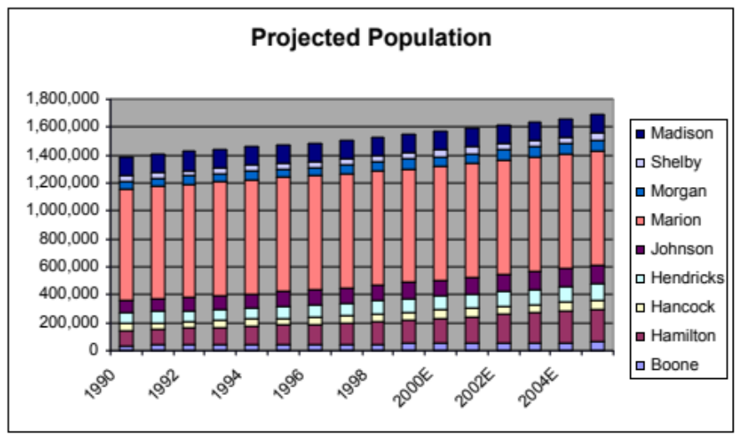
The total market forecast for the Indianapolis Metropolitan area is based on population growth rates and pet ownership demographics. The 5 year total market forecast for the Indianapolis pet care market is:
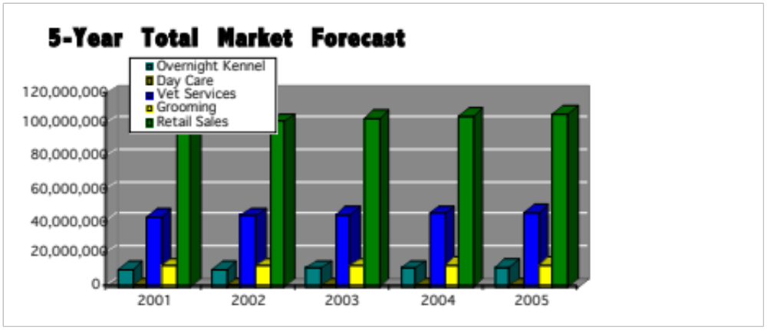

Competitive Factors
We will be seeking accreditation from the American Boarding Kennel Association (ABKA). This will be a very strong competitive advantage in the pet care industry. The market is a very fragmented market with many “Mom and Pop” kennels that have been started up as a hobby and grown into a family business. The leading competitor in the market is Best Friends Boarding Kennels. They have an average occupancy rate of approximately 50%. There are currently 59 boarding kennels in the Indianapolis Metropolitan area.

Macroenvironmental Influences
Achieving proper zoning in the areas for our locations will be our largest environmental hurdle. This could be the stumbling block that causes the entrepreneurs to abandon our plan entirely. We will make a concerted effort to gain the good will of our neighbors as we consider our relationships within the community. We will actively seek to contribute to the community and help to improve the areas surrounding our locations. As a result of their exclusive indoor design, our facilities will be harmonious with their environment.

Development and Production
A Pampered Pet is a pet care center for the boarding of family pets (cats and dogs). The objective is to offer care second to none. Clients will feel assured when leaving their family pet that they will be cared for as well as if at home.

Facility
The basic construction of our facility and business is based upon guidelines provided by the American Boarding Kennel Association (ABKA). The business has been developed around competitive analysis as well as working for an ABKA accredited pet care facility. The CEO for assistance in the preparation of our plan attended the Buy, Build and Operate (BBO) seminar provided by ABKA.
The facility is designed to board cats and dogs, provide grooming services, provide veterinarian service and provide for retail sales and pet day care. The pet care facility is designed to provide upscale accommodations for each pet. Suites are designed to be larger and totally indoor. Indoor suites reduce noise, eliminate drafts and insect pests that may create problems for the guests (fleas, flies, ticks, etc.). The suites have been designed to make the most efficient use of pet care labor. T-Kennel has been selected to supply the suites. Each suite contains a couch type bed and wall decoration. Each suite has a window for natural light and viewing the outdoors. Each suite is sanitized on a daily basis via our custom, automated sanitizing system and designed to eliminate cross contamination. Filtered water is provided via our automatic watering system. All bowls and the watering system are stainless to provide for the healthiest of environments. The suites are air conditioned and heated and have radiant heated zones on their concrete floors. The heating and cooling system is also equipped with air filtration. The facility is protected by a fire/security system. Pets are cared for by certified and tested pet care technicians. Each technician is responsible for 36 pets at 65%-projected capacity. All pet food consumption and elimination is charted on a daily basis. Any other noted conditions are reported immediately. Medication is dispensed for those pets requiring such care. The pet owner may provide food. A Pampered Pet exclusively feeds the premium product Science Diet. All meals are prepared in kitchens in each suite section. This assures proper feeding and improves the efficiency of completing this task. Suites can be provided with color TV or an Internet cam for an additional charge. Fifteen-minute playtimes can also be incorporated with a pet’s stay for an additional charge per playtime. Pets will be bathed prior to their departure at no cost to the pet owner.

Operating Hours and Employee Ratios
Operating hours for the pet care center will be 8am – 6pm Monday through Friday, 8am – 5pm Saturday and 3pm – 6pm on Sunday. Three full-time Pet Care Technicians, two Playtime Providers and a Facility Manager will operate the pet care center. Individual contractors of A Pampered Pet will provide veterinarian service and grooming services. All equipment, facilities and maintenance will be provided for a percentage of the gross of both services. Six part-time employees will be required to cover weekends and during holidays and full-time employee vacations. Each part-time employee will be tested and certified. We intend to attract the highest quality employees by providing earning potential above all other pet care facilities and other businesses requiring semi-skilled workers. There will also be the opportunity for advancement as we start future pet care centers. Attitude is the most important qualification we will look for in a potential employee. Our working environment will be safe, rewarding and comfortable. The pet to technician ratio will be maintained to allow each technician time to care for each pet’s basic needs of feeding, watering and cleaning. We more importantly want to assure time for loving the pets.
Fencing to assure the safety of each pet will protect all areas of the pet care facility. Play areas and nature walk areas will be equipped in an effort to make the pets stay very rewarding. Covered outdoor play areas are provided for those times when weather conditions are not optimal for the pet or their caregiver. Two indoor play areas are provided for those really nasty days.

Job Roles and Responsibilities
The Pet Care Center Manager will check-in each pet. No pet will be allowed to stay without proof of vaccinations and a flea check. Those pets found to have fleas will not be allowed to stay without first receiving a flea removal bath at the owner’s expense. No aggressive animals will be accepted. A full profile of each pet will be input to our database along with the completion of all waivers. The owner can order additional services at check-in, contact us by phone or log-on to our Internet site to do this at any time. Owners requesting video access to their pets can also set-up time blocks for this. The owner and a pet care technician can either lead the pet to their suite or the pet care technician can do this. All pets going home are bathed and reunited with their owners in a receiving area of our center.
Pet Care Technician: Each technician will be certified via ABKA. Job responsibilities will include, feeding, watering, cleaning, charting and general pet care. Medications will be provided to those pets requiring such care.
Playtime Provider: Each will also have ABKA training. Job responsibilities will include playtimes and walks on the nature trail. The Playtime Providers will also see that the play areas and nature trail are properly maintained and cleaned.
Facility Manager: Customer contact, check-in and day to day facility activities. This individual will hold the ABKA rank of Certified Kennel Operator (CKO).
Our first pet care facility will be located on a five-acre tract of land north of Carmel, Indiana (Hamilton County). Current negotiations indicate a purchase price of $20,000.00 per acre. This location is considered rural. A second location near Whitestown (Boone County) is being considered as a backup location. All zoning regulations have been fully researched. Resistance to this proposal appears very limited at best. Future locations will be sought near points of access to the metropolitan Indianapolis area. Rural settings will be sought if possible to reduce real-estate costs and the potential for zoning conflicts.

Marketing

Overall Concept and Orientation
A Pampered Pet exists to serve its guests (pets) and their owners. Exceeding their expectations is our number one priority. We provide a safe, comfortable and fun environment for our guests. We also provide pet owners the peace of mind in knowing that their pet is enjoying the best possible care in the best possible environment.
The main resource that will create this customer-focused environment are the employees. The firm will continually invest in its employees to attract and retain the best possible staff.

Marketing Strategy
A Pampered Pet will cater to its customers needs utilizing the right Product, Place, Price and Promotion strategies.

Product
Our primary product is premium pet care. The uniqueness of the product is in the upscale nature of the Pet Care Center. The consumer who chooses our services is interested in providing their pets distinctive care that is the same they would provide at home. Premium service and unique products are what we have to offer. Some of which are unavailable at any other like facility.

Price
The price of $19 per overnight stay is currently 1$ over the closest competitor’s price. This price is justified by both the real and perceived value of the product.

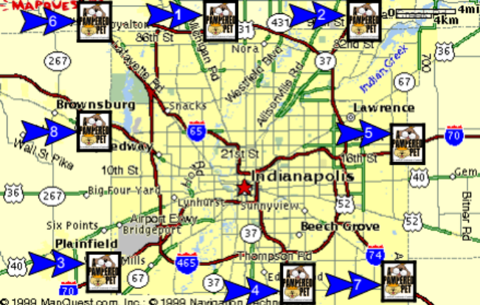Place
Kennels will be located at the eight major entry and exit points coming into the Indianapolis metropolitan area. As the customer is on their way out of town they will be able to conveniently drop off their pet and then quickly pick them up on their way back home.

Promotion
Initial exposure and promotion of each new facility will be accomplished through a combination of the following promotional activities:
- Issuance of press releases to local and national media (see Appendix material)
- Radio advertisements and onsite live broadcast
- Yellow page advertisement
- Mailings to local Veterinarians to facilitate referral business
- Referrals and recommendations from current customers
We will maintain a customer database with information on all pets that are boarded in our kennel. We will do follow up phone calls to verify the quality and happiness of the pet after their stay with A Pampered Pet. We will do periodic mailings in targeted areas to advertise our facilities and to survey the needs of our customers.
All marketing efforts are coordinated exclusively around the safe and secure boarding kennel environment we will be offering to the market. We will be seeking to deliver quality care at a premium value to the customer. Promotion will be through advertising, word of mouth and working through veterinarians. A web page will be available to our customers where they will be able to schedule their pet’s stay. We will also provide web-cam capability so that the owner will be able to view their pet and see how they are doing at any time. They will also be able to log on and order treats for their pets or another playtime to pamper their pet. Our overall goal is to give the owner peace of mind knowing that their pet is being taken care of well.

Sales Forecasts
A Pampered Pet will cater to these customers needs utilizing the right Product, Place, Price and Promotion strategies. The fragmentation of the market, combined with the average low quality of the Indianapolis kennels provide a significant opportunity to quickly establish a high quality and value reputation and obtain significant market share. This will be accomplished through targeted marketing to pet owners through veterinarians and radio broadcast advertisements.
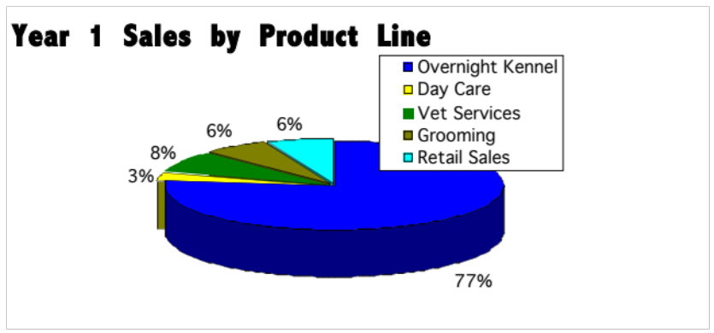
Based on opening a total of eight sites of operation over a five-year period (covering the eight major entry and exit points to the city) we estimate that we can achieve a 40% market share in the Indianapolis market. This projection is based on a conservative 65% occupancy rate. (Minimum breakeven point is 32%.)
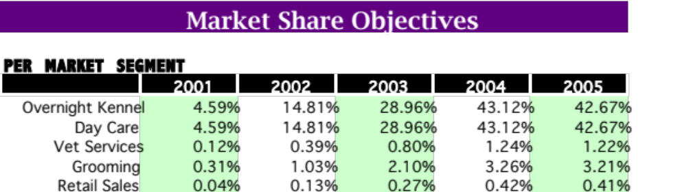
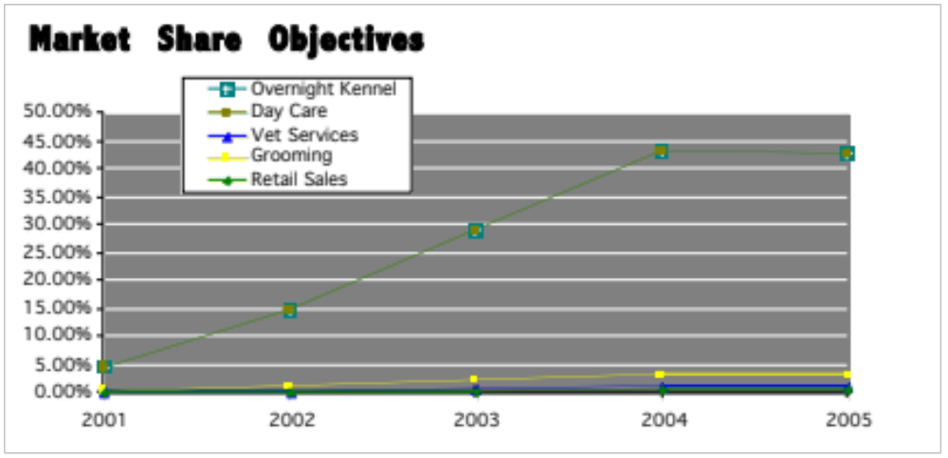
Based on our premium value pricing strategy, we expect the following sales in our operations:
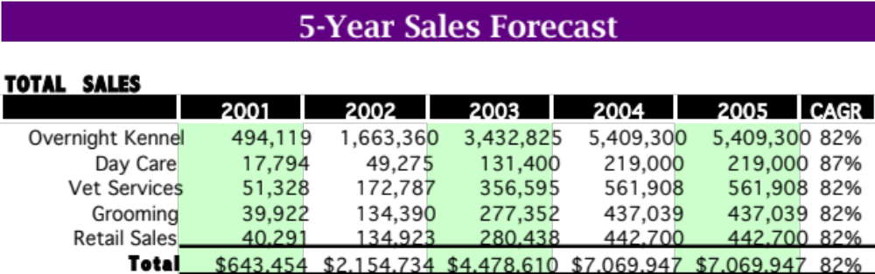
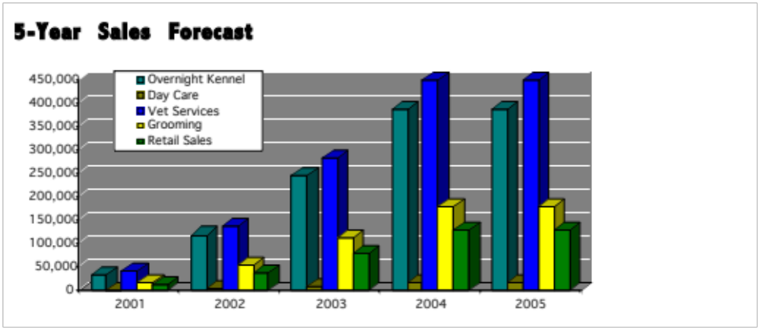

Financial Plans
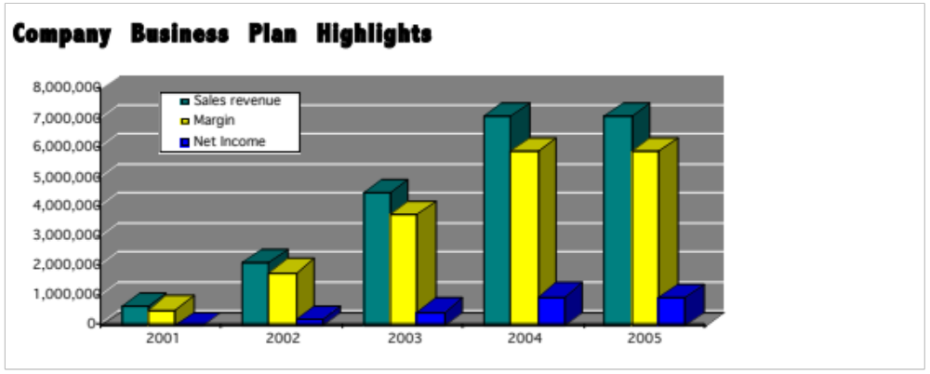
A summary of the financial projections for A Pampered Pet show that sales revenue is expected to increase from $643 thousand in 2001 to $7.07 million in 2005 when all eight pet care facilities are online. This represents a compounded annual sales growth rate of 82%. Over this same period, annual profits are expected to increase from $7 thousand to $944 thousand, at a compounded annual growth rate of 49%. Sales and net income are expected to level off following the opening of the final facility. While not assumed or projected, it is expected that as the concept is proven out, other cities will be targeted for expansion. The possibility of franchising the concept is a definate possibility to enable continued growth.
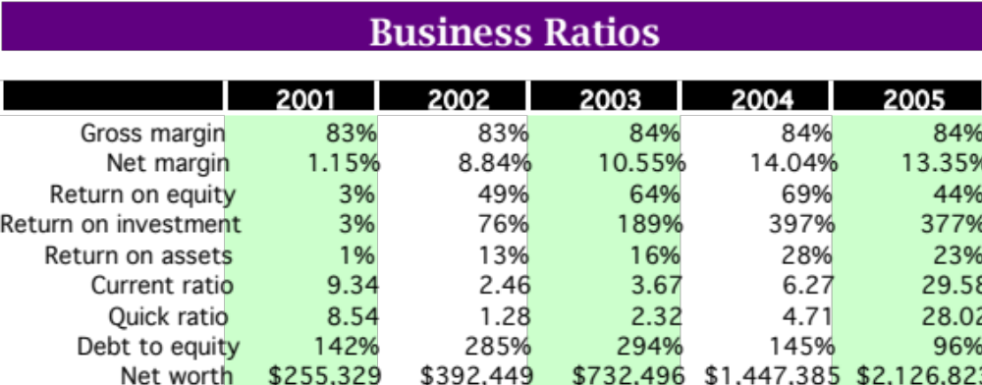
Operating at a gross margin of 83% and an ultimate net margin of 13%, Return on Equity is projected at 44% in 2005, with a return on investment of 377%. The assets of A Pampered Pet are expected to yield an average return of 23% by 2005.
(Note: all financial projections and estimates were developed using statistics from ABKA for pet care facilities of 100 runs or larger.)

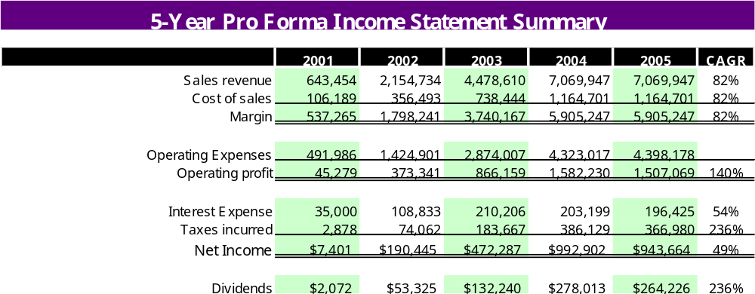
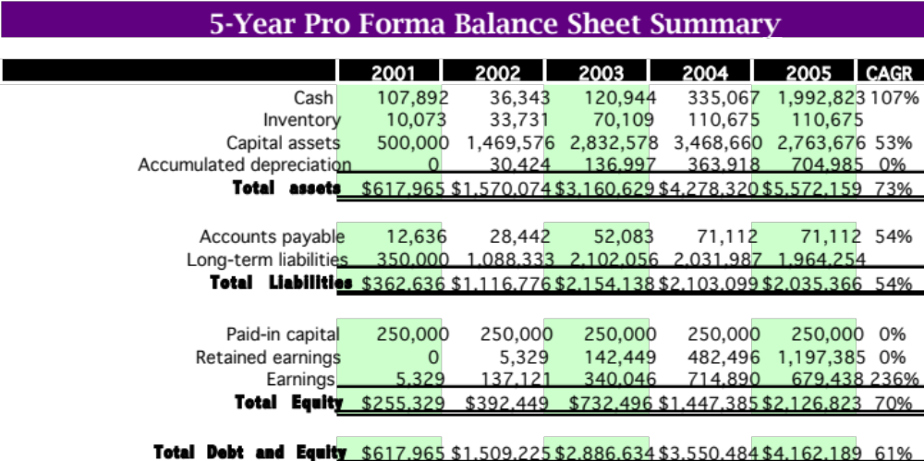
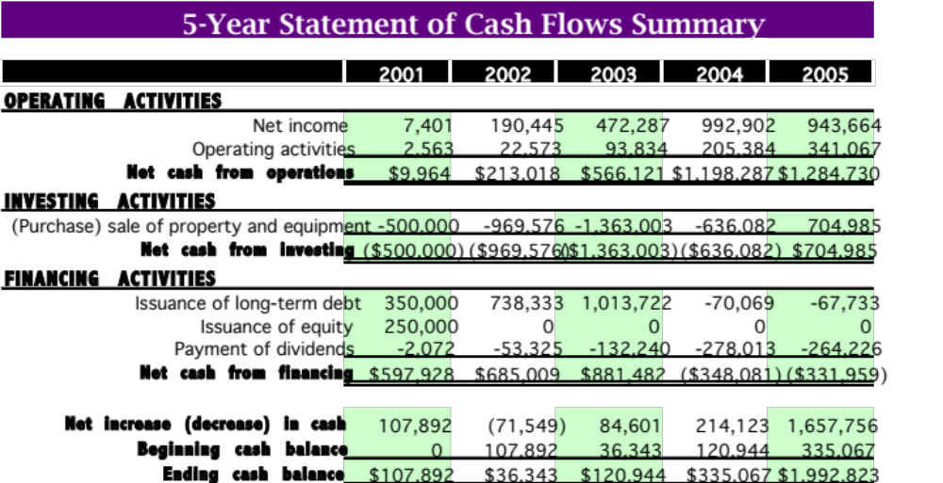
Appendix A contains full copies of the financial statements and projections.

Break-Even Analysis
Derived from ABKA statistics, it is assumed that the average sale from a pet’s stay at A Pampered Pet is $141 (including kenneling, grooming, retail and vet services). Given this assumption, the break-even analysis for A Pampered Pet is as follows:
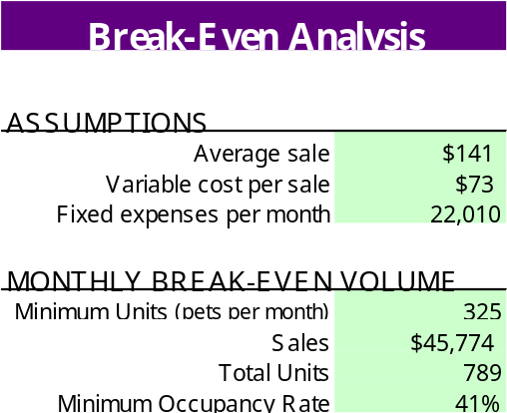

Financial Resources
Start up costs for A Pampered Pet are projected to be $574,742, broken down as follows:
General and Administrative Expenses $23,166
Sales and Marketing Expenses 35,050
Other Expenses 5,000
Retail Inventory 1,525
Opening Cash 10,000
Land, Building and Equipment 500,000
Total $574,742

These start-up expenses are to be covered by the following sources of capital:
Owner’s Equity - $50,000 per owner (42% of total capital) $250,000
Bank Loan (secured with the facility at 70% LTV) 350,000
Total Start-up Capitalization $600,000
Each pet care facility is estimated to cost $500,000. Bank loans will be repaid over a thirty-year time period.
A total of eight facilities are planned, covering all of the major entrances and exits to and from the Indianapolis Metropolitan area. Financing for these facilities will be required as follows:
Facilities 2, 3 (online by 2002) 75% LTV 750,000
Facilities 4, 5 and 6 (online by 2003) 70% LTV 1,050,000
Facilities 7 and 8 (online by 2004) No Loans Needed

Financial Strategy
Bank debt financing will be used to quickly open the eight facilities needed to achieve the market coverage of A Pampered Pet. Loans will be secured to fund the purchase and construction of the pet care facilities. The land and facilities will be offered as collateral to the loans.
It is the preference of the owners for growth to be funded internally and through the issuance of debt, backed by the pet care facilities with loans taken at a maximum of 75% loan to value. The owners believe that their continued high equity position, in addition to the lower cost of debt financing is the proper source of funds for the business.
As growth is achieved, future financing will be obtained at lower loan to value ratios as the capital assets of the business grow larger. It is expected that excess cash generated from operations will be redeployed in the business to enable growth with decreasing levels of debt
In the future, as the concept of A Pampered Pet proves successful, a franchising strategy may be enacted to enable the rapid national growth of the business. If this scenario arises, further sources of capital may be sought in equity markets.
Because of the tax implication for the owner’s of A Pampered Pet, a dividend of 28% of the net income of the business will be taken by the owners to cover personal tax liabilities. Future dividend decisions will be made at the discretion of the Board of Directors and will depend on the financial experience of the business.
All disbursements, expenses and cash handling procedures will come under the control and supervision of the Chief Financial Officer of A Pampered Pet. Cash registers used in the pet care facilities will be linked via a virtual private network, with data consolidated in a financial database. Cash drawers will counted down at the end of each day. Cash handling integrity will be the responsibility of the pet Facility Managers. A Pampered Pet will secure the services of Ernst & Young LLC as external auditors.

Organization and Management

Key Personnel Resources
The five owners will each take important roles in the company.
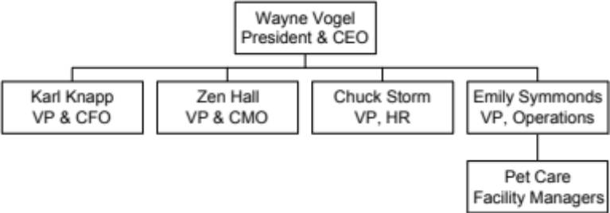
Two key positions remain unfilled, a veterinarian and a Groomer. They will not be considered employees. A Pampered Pet will contract the two. We will be looking for a veterinarian that has recently graduated from veterinarian school and wants to start their own business. The Groomer must have at least three years of grooming experience. The Groomer must have extensive training in all areas of the grooming arena. A Pampered Pet will give the veterinarian and the Groomer free space to conduct their business. The company will take a percentage of their sales as payment.
It is currently planned that the owners will receive dividends of 28% of net income to cover personal income taxes incurred. Future dividend decisions will be based on the financial performance of the business.
A Pampered Pet’s owners will have significant ownership stakes in the company. The company will offer employee benefits and higher that standard wages as a way to attract the firm’s key personnel. As A Pampered Pet establishes more pet care centers, training and promotions will rise. This will also help develop and retain personnel. One opportunity, for example, would be to provide tuition reimbursement for employees that have the desire to become a veterinarian with the intention of coming back to A Pampered Pet to work as a veterinarian.
The owners will sign non-compete contracts with A Pampered Pet. They will be prohibited from working for another pet care center during the first three years A Pampered Pet conducts operations and for twelve months after they leave A Pampered Pet.
The following accounts for A Pampered Pet’s board of directors:
- Wayne Vogel, 40, previous pet care center experience, President, CEO, Chairman of the Board and owner of A Pampered Pet.
- Karl Knapp, 34, extensive Informational Technology experience, CFO and owner of A Pampered Pet.
- Mark Steckbeck, 45, lawyer, part of the legal team at Indianapolis Life, friend of owners.
- Bill Cunningham, 50, head of multiple divisions, works at Federal Mogul, friend of owners.
- Greg Heberling, 45, entrepreneur and professor, professor at Anderson University and business owner, friend and prior professor of owners.

Human Resource Management Strategy
The main resources that will create this customer-focused environment are the employees. The firm will continually invest in its employees to attract and retain the best possible staff.
A Pampered Pet favors general supervision. Unionization is not expected. Employee compensation will be higher than industry average. Profit sharing and employee ownership is not in the plan at this time, but could happen in the future. A Pampered Pet strives to keep and attract dedicated, hard-working and qualified employees.
A Pampered Pet will not incur future liabilities on behalf of its employees. The company will not sponsor a defined-benefit or defined-contribution pension plan. The company will try to pool with other small businesses and receive discounted health insurance rates.
The owners of A Pampered Pet will perform a vast majority of the day to day tasks of operating a pet care center. The company will need medium to high skilled, minimum high school education and willing to learn full-time employees. Part-time employees will be needed also. Training and pet care education will be available for the employees. The Pet Care Technician program offered by the ABKA will be required by all full-time employees. Continuing education that is offered by the ABKA will also be available. The three-step program offered by the ABKA is encouraged. When finished with the third level, the employee can enter the Certified Kennel Operator Program. The education offered and performance will dictate criteria for promotion of full-time employees. Performance will be assessed by a review for the first three months and then every six months thereafter.
The labor market is competitive at this time. The skills are available, but the unemployment rate is at an all time low. A Pampered Pet must offer a higher rate of pay and employment growth opportunity to attract the level of skill that is needed.
All applicants and employees will be treated with the EEOC laws in mind.

Ownership

Form of Business
A Pampered Pet will be organized as a limited liability corporation (LLC). This type of legal structure allows for corporate profits to be passed on to the owners as dividends without being taxed first as income to the corporation. A LLC limits the liability exposure of the investors only to the money they have placed in the company. Another advantage to this type of legal structure is there are no restriction on investors in the company should the founders need to seek additional capital through this channel.

Equity Positions
A Pampered Pet will begin with 25,000 shares of preferred stock. The shares will be distributed to the co-owners in an amount of 5,000 each at a par value of $10.00 per share. Due to the projected speed of our growth, the owners will only have the right within the first five years of the business to sell any of their shares to the other co-owners.

Deal Structure
A Pampered Pet will be owned by the five individuals starting the business. Ownership will be divided equally, based on an equal contribution of capital to the business.
Owner Capital Contribution # of Shares %
Wayne Vogel $50,000 5,000 20%
Karl Knapp 50,000 5,000 20%
Zen Hall 50,000 5,000 20%
Emily Symmonds 50,000 5,000 20%
Chuck Storm 50,000 5,000 20%
Total $250,000 25,000 100%

Start up costs for A Pampered Pet are projected to be $574,742, broken down as follows:
General and Administrative Expenses $23,166
Sales and Marketing Expenses 35,050
Other Expenses 5,000
Retail Inventory 1,525
Opening Cash 10,000
Land, Building and Equipment 500,000
Total $574,742
These start-up expenses are to be covered by the following sources of capital:
Owner’s Equity - $50,000 per owner (42% of total capital) $250,000
Bank Loan (secured with the facility at 70% LTV) 350,000
Total Start-up Capitalization $600,000
Return on investment from the owner’s initial contribution is estimated to be 377% over a five-year period.

Critical Risks and Contingencies
Any new business venture is not without risks. Success is not guaranteed because our financial assumptions appear to make it so. Those risks that pose the largest concerns are as follows:
- Unproven startup business management and only one founder has significant industry experience.
- If the market for upscale pet care centers is less than we anticipate, future expansion and profitability will be harder to achieve.
- Our ability to acquire proper staffing due to tight labor market in the metropolitan area of Indianapolis.
- Inability to obtain locations or zoning changes in the strategic areas we have identified.
- Our ability to obtain the needed funding now and into the future.
Some lessor concerns, though still of importance, are items such as a downturn in the economy resulting in reduced utilization of our services. Our largest competitor, Best Friends, has the financial resources to pursue the same strategy that we propose and may chose to protect their market share.

Conclusion

Summary and Conclusion
A Pampered Pet is a premium value pet care facility. Our primary product is the overnight kenneling of dogs. We also offer retail products, pet day care, grooming and veterinary services.
The market for this business has great potential. The current market is fragmented by a large number of very small, owner-operated kennels of moderate to low quality. Given the trends in pet ownership and the fragmentation of the market, A Pampered Pet is perfectly positioned to achieve rapid market penetration and garner market share of up to 43%.
This growth will be initially funded through a combination of owner’s equity ($250,000) a 30-year bank loan of $350,000. The bank loan will be secured with the land and pet care facility offered as collateral. Additional bank loans are planned once the initial concept facility is proven successful at decreasing loan to value against the assets and land purchased.
Profitability will reach 44% return on equity and 377% return on investment in the fifth year of operation. Once the last facilities are opened, operating profits are projected to be over $900 thousand per year, at 13% net margin.
The management team assembled to make A Pampered Pet reality is highly qualified. Led by Wayne Vogel, who has extensive experience with pet care centers, the management team has the breadth of experience necessary to achieve the projected results.

Scheduling and Milestones
Milestone | Date
Incorporation of A Pampered Pet | 05/01/2000
Bank Loan Secured | 05/01/2000
Land Purchase Executed | 06/01/2000
Construction Started | 07/01/2000
Veterinarian Agreement Signed | 11/01/2000
Employees Hired | 12/01/2000
Construction Completed | 12/01/2000
Extensive Employee Training Completed | 12/18/2000
A Pampered Pet Opened for Business | 12/18/2000
Facilities 2 and 3 Opened for Business | 12/18/2001
Facilities 4, 5, and 6 Opened for Business | 12/18/2002
Facilities 7 and 8 Opened for Business | 12/18/2003

Appendices

Appendix A – Financial Statements

Start Up Needs
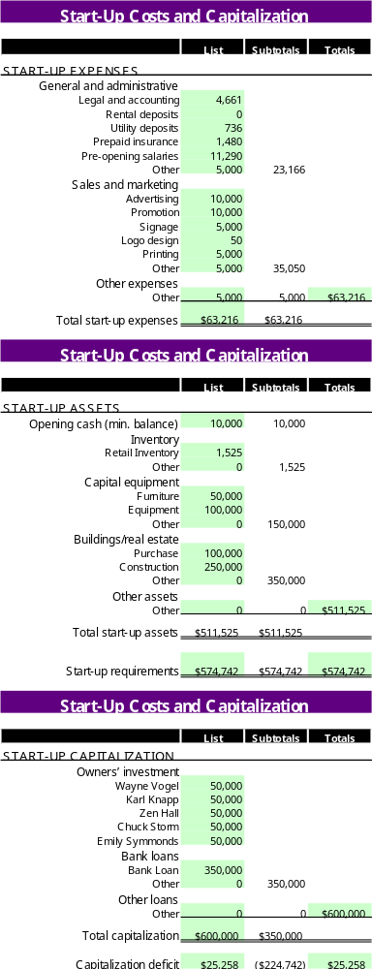

Year One Forecast
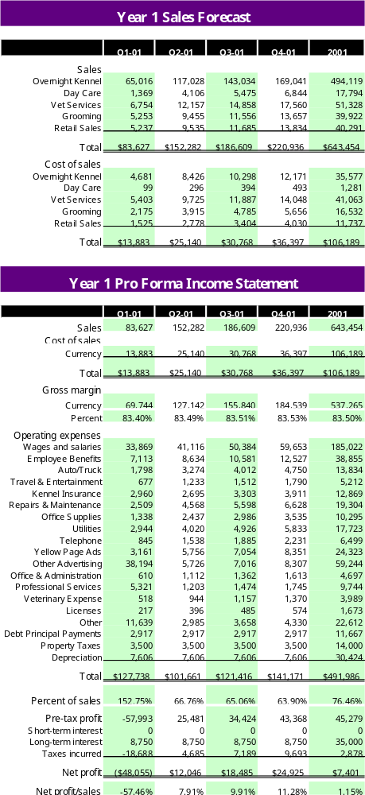

Sales Forecast

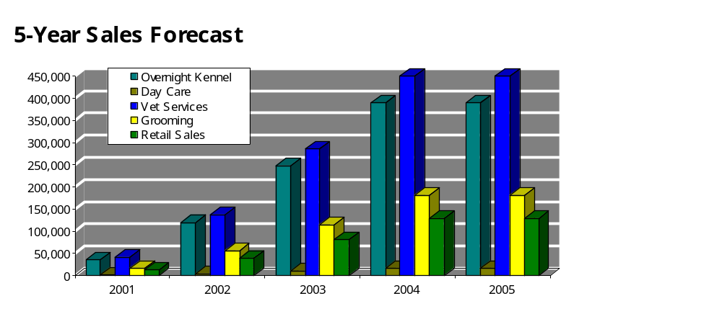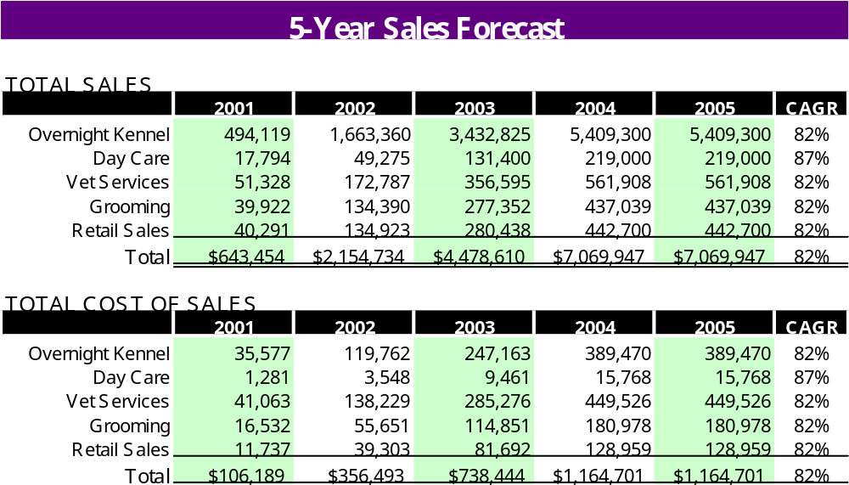

Income Statement
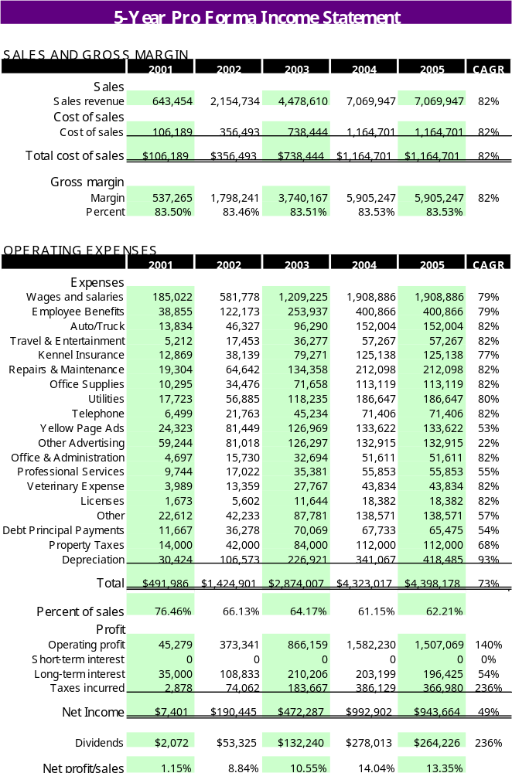

Balance Sheet
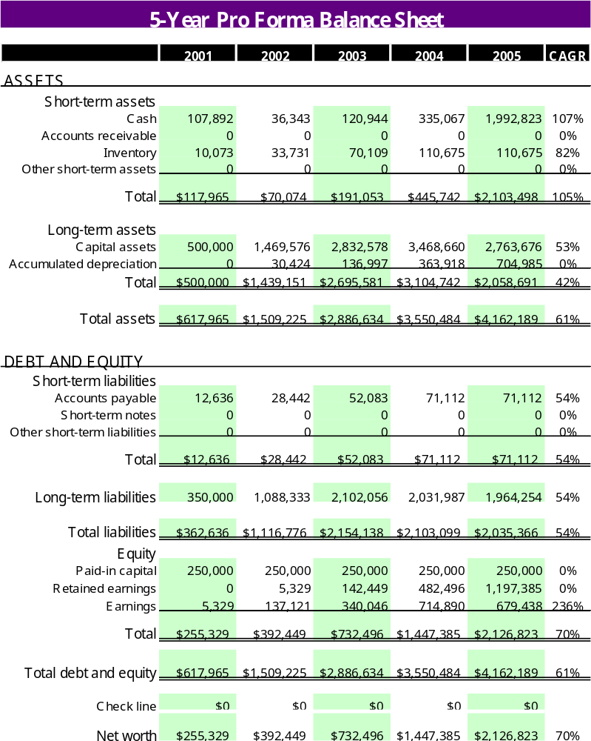

Cash Flow Statement
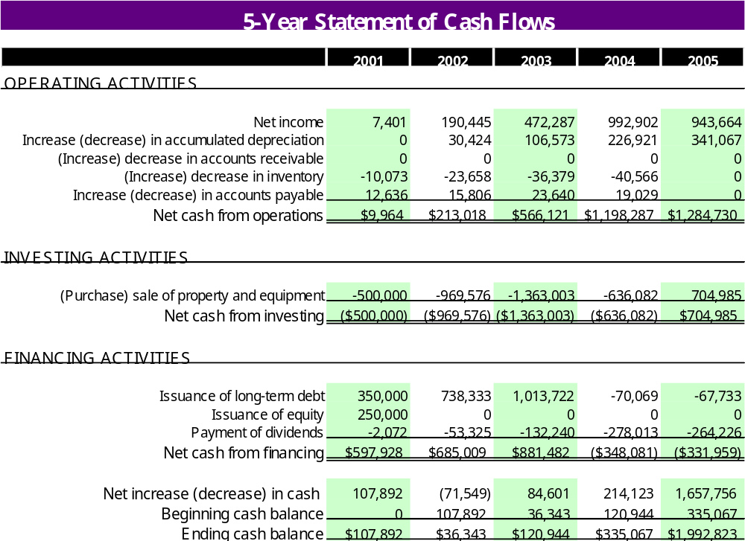

Appendix B – Pet Care Facility Schematic

Appendix C – Marketing and Pricing Brochure

Appendix D - Population Surveys and Statistics
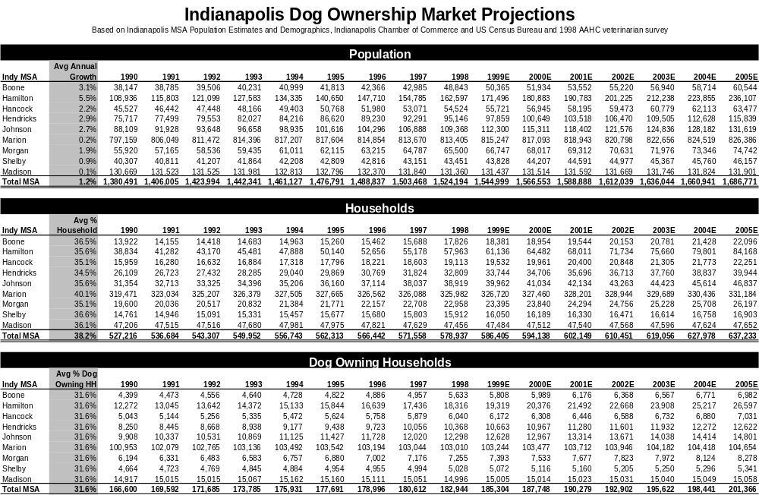
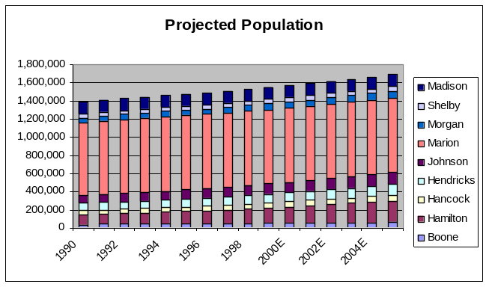
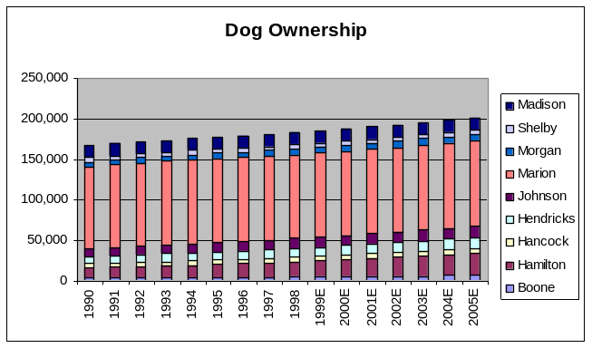

Appendix E – Competition Survey
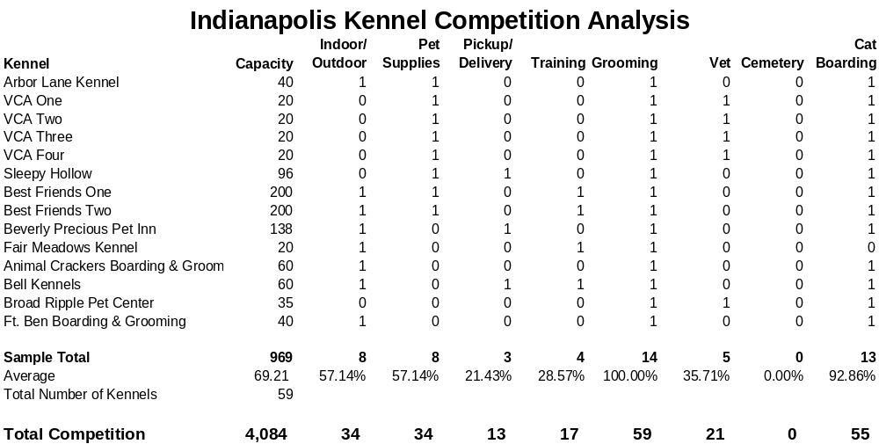

Appendix F – Press Release


Appendix G – Owner Resumes

