..,
u
Q)


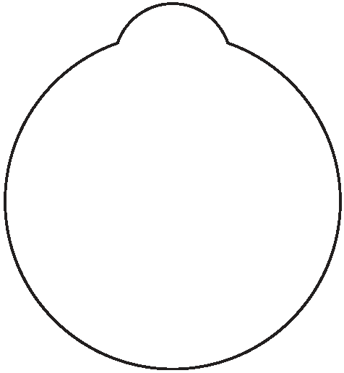

door hanger template

t(.c.reafit ify Portal Ttl

Design Your Own
Door Hanger

Suggested Instructions:

1. Print this page on thick paper or card stock.

2. Carefully cut out template with scissors or craft knife.

3. Design your door hanger message in any way you choose. Use your computer to create words and pictures - or draw, color,collage,paint,or stamp
on your own designs. Use your
imagination! The creative possibilities are endless.Make a reversible door hanger by sticking two templates together back-to-beck.

4. When the door hanger design is finished,you may want to seal it with Mod Podge or clear,self-adhesive laminating sheets for protection and durability.

Downloaded from the Creativity Portal Web site (www.creativity-portal.com) for personal,non-commercial use only.
© 2006 Chris Dunmire

